Checklist
Kick-off meeting

Meeting / Project name:
Date: |  | Start:
Location: |  | End:
Moderator: |  | Minutes:

1. Basic preparations
To-Do’s |  | Done
 | Define project goals and scope, clarify key points with the project initiators or the customer
 | Define the project team
 | Clarify responsibilities
 | Define the meeting schedule and agenda in detail
 | Preliminary project planning (schedule, budgeting, resource planning)
 | Enter further individual to-do's here if necessary

2. Organizing the meeting
To-Do’s |  | Done
 | Determine meeting participants
 | Set the time, place, and duration of the meeting
 | Book a suffienciently sized room with required equipment (check availability of beamer, notebook, flipchart etc.)
 | Send out invitations to the meeting
 | Prepare the presenations of the project
 | Send the agenda and preliminary project plan to all participants, no later than two days before the kick-off meeting
 | Prepare documents to be distributed to the participants
 | Appoint someone to take meeting minutes
 | Prepare respective agenda items
 | Optional: Catering and drinks
 | Enter further individual to-do's here if necessary

3. During the course of the meeting
Opening |  | Done
 | Welcome and introductory words by the project manager
 | Presentation of the meeting agenda
 | Introductory round
 | Enter further individual to-do's here if necessary
Course of the meeting according to planned agenda |  | Done
 | Enter your agenda items here
Ending |  | Done
 | Feedback, Q&A
 | Evaluate the mood in the team
 | Optional: Relaxed winding-down/networking
 | Enter further individual to-do's here if necessary

4. Follow-up
To-Do’s |  | Done
 | Make a clean copy of the meeting minutes and send to all the participants
 | Make a clean copy of the Q&A and elaborate where necessary
 | Adjust the project plan if necessary and send to all the participants
 | Enter further individual to-do's here if necessary

Building blocks for kick-off meetings

Let's first look at the potential agenda of your kick-off meeting. In principle, a kick-off event can consist of any one or more elements. Quite often, presentations of the customer and/or the project manager take place first. Here you can present the main project objectives and provide an initial overview of, for example:
- Vision
- Goals
- Budget
- Project plan (e.g. important milestones, start- and end-dates)
You should also explain the principles of project communication and cooperation. In teams that have never worked together before, it is important to establish concrete communication rules. These include, for example:
- Important contact persons e.g. within the team, in the PMO or the customer’s organization
- Defining the primary means of communication and processes
- Establishing feedback loops and error reporting to react to change requests quickly
- Setting rules for documentation and document management
In case of larger projects, such as federal construction projects, press conferences are also held or selected press representatives are admitted to certain parts of the kick-off event. Such projects are usually accompanied by professional project marketing.

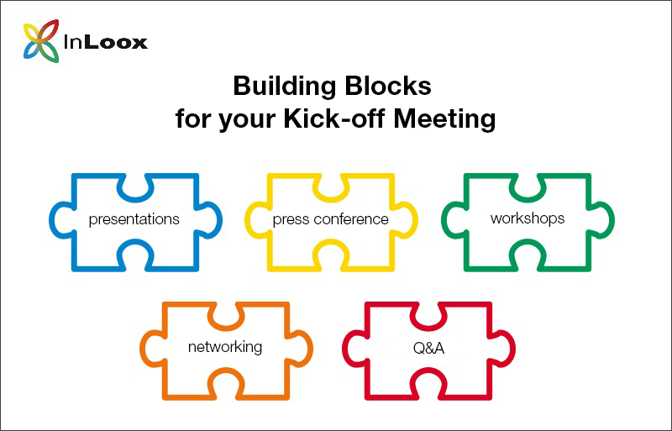

An integral part of kick-off meetings are workshops. They can be designed for various goals:
- Getting to know each other
- Discovering each other’s skill sets
- Exchanging lessons-learned (or retrospectives for agile teams) from previous, similar projects
At the end of a kick-off meeting, you should leave enough time for questions. Also, make sure that you summarize the points discussed during the kick-off meeting and consider the next steps in the project’s execution. And, of course, don’t forget to provide time and space for a relaxed winding-down and opportunity to network afterwards.

